Part A. Ordered Logit Models
The ordered logistic HGLM was run with degree attainment predicted by gender, race, and base-year SES. All of these predictors were left uncentered and the slopes were treated as fixed. The outcome is coded so that 0 = BA graduate, 1 = high school graduate, and 2 = less than high school. Therefore, larger outcome values represent lower educational attainment.

Output from the first ordered logit model
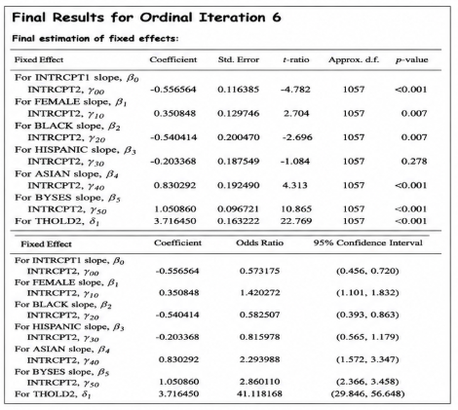

Q1. Interpretation of the intercept, Black coefficient, SES coefficient, and threshold
Effect | Coefficient | p-value
Intercept | -0.5566 | < .001
Female | 0.3508 | .007
Black | -0.5404 | .007
Hispanic | -0.2034 | .278
Asian | 0.8303 | < .001
BYSES | 1.0509 | < .001
Threshold δ₂ | 3.7165 | < .001
The intercept is -0.5566. It refers to the log-odds for the reference student, meaning a white male student with BYSES equal to 0. Since the outcome categories are ordered from BA graduate to less than high school, the sign of the coefficient must be read together with the coding of the dependent variable.
The Black coefficient is -0.5404 and is statistically significant at p = .007. Holding gender and SES constant, Black students differ from white students by about -0.54 in the log-odds scale. With this coding of DEGREE, the negative sign suggests lower odds of being in the lower-attainment categories relative to white students, although the interpretation should be stated carefully because the categories are reverse-coded.
The coefficient for BYSES is 1.0509 and is highly significant. A one-unit increase in base-year SES changes the log-odds by about 1.05, net of race and gender. Because the coding of the outcome runs from higher attainment to lower attainment, this coefficient has to be interpreted in relation to the ordered-logit cutpoints rather than as a simple linear change in years of schooling.
The threshold δ₂ is 3.7165. This parameter gives the distance between the first and second cumulative logits. It helps separate the BA-graduate category from the combined lower-attainment categories in the ordered response scale.

Q2. Log-odds for a Black student with SES = 1
For a Black student with BYSES = 1, the log-odds for the first cumulative comparison are calculated by adding the intercept, the Black coefficient, and the BYSES coefficient:
-0.556564 + (-0.540414) + 1.050860 = -0.046118
Thus, the estimated log-odds are approximately -0.046. Converting this logit to a probability gives about 48.85 percent for the first comparison.
To include high school graduates along with BA graduates, the threshold is added to the calculation:
3.716450 - (-0.046118) = 3.762568
This gives a cumulative log-odds of about 3.763, which corresponds to about 97.73 percent. Substantively, the second calculation is much larger because it includes a broader category: students with at least a high school degree rather than only BA graduates.

Q3. Wald test comparing the Black-white and Hispanic-white gaps
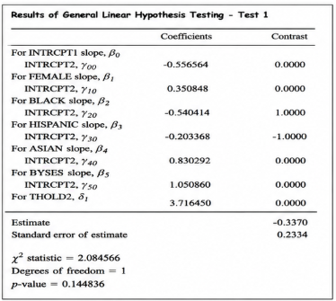

The null hypothesis for the Wald test is that the Black-white gap is equal to the Hispanic-white gap:
H₀: β_Black = β_Hispanic
The Wald test gives χ² = 2.0846 with 1 degree of freedom and p = 0.1448. Since this p-value is larger than .05, I fail to reject the null hypothesis. Therefore, the model does not provide enough statistical evidence that the Black-white gap differs from the Hispanic-white gap.

Q4. Adding Catholic school at level 2
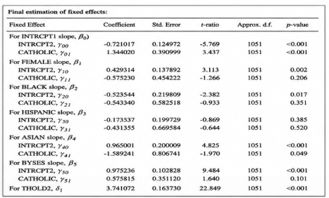
In the second model, Catholic school was added at level 2 for each level-1 term. The public-school intercept is now -0.7210, while the Catholic effect on the intercept is 1.3440 and statistically significant. This means the estimated intercept differs between public and Catholic schools.
For the demographic slopes, most of the Catholic interactions are not statistically significant. The Female × Catholic interaction is -0.5752 with p = .206, the Black × Catholic interaction is -0.5433 with p = .351, the Hispanic × Catholic interaction is -0.4314 with p = .520, and the BYSES × Catholic interaction is 0.5758 with p = .101. These results do not give strong evidence that Catholic schooling changes these particular relationships.
The main exception is the Asian × Catholic interaction, which is -1.5892 with p = .049. This is statistically significant at about the .05 level, although it should be interpreted cautiously because it is only one interaction among several tested. The results suggest that Catholic school status matters for the intercept and matter for Asian students, but the model gives limited evidence that Catholic schooling broadly changes the effects of gender, Black race, Hispanic ethnicity, or SES on educational attainment.

Part B. Cross-classified Models
For Part B, the outcome is ATTAIN. Students are cross-classified by neighborhoods and schools rather than being strictly nested in only one grouping structure. P7READ and DADOCC are grand-mean centered, while the binary variables are left uncentered.

Q1. Model and interpretation
$$\begin{matrix}ATTAIN_{ijk}= & π_{0}+γ_{01}DEPRIVE_{j}+γ_{10}P7READ_{ijk} \\ & +γ_{11}(P7READ_{ijk}×DEPRIVE_{j}) \\ & +γ_{20}DADOCC_{ijk}+γ_{21}(DADOCC_{ijk}×DEPRIVE_{j}) \\ & +γ_{30}DADUNEMP_{ijk}+γ_{31}(DADUNEMP_{ijk}×DEPRIVE_{j}) \\ & +γ_{40}MALE_{ijk}+γ_{41}(MALE_{ijk}×DEPRIVE_{j}) \\ & +b_{00j}+c_{00k}+e_{ijk}\end{matrix}$$
The intercept π₀ is the expected attainment for the reference student: a female student, with average prior reading achievement and average father occupational status, whose father is employed, and who is not living in a deprived neighborhood.
The coefficient γ₀₁ represents the difference in attainment between students in deprived and non-deprived neighborhoods, holding the child-level covariates constant. The coefficients γ₁₀, γ₂₀, γ₃₀, and γ₄₀ represent the effects of prior reading, father occupational status, father unemployment, and gender among students in non-deprived neighborhoods. The interaction terms show whether those child-level effects change when the student lives in a deprived neighborhood.
The random neighborhood term b₀₀ⱼ captures remaining differences among neighborhoods, averaged over schools. The random school term c₀₀ₖ captures remaining differences among schools, averaged over neighborhoods. The residual eᵢⱼₖ represents the individual student-level deviation from the predicted outcome.

Q2. Association between neighborhood deprivation and achievement

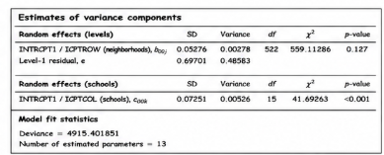
The coefficient for DEPRIVE is -0.1779 with p < .001. This indicates that, after controlling for prior reading achievement, father occupation, father unemployment, and gender, students in deprived neighborhoods have significantly lower expected achievement than students in non-deprived neighborhoods.
The evidence is statistically strong because the p-value is far below .05. Therefore, I would conclude that neighborhood deprivation is associated with achievement even after the child-level covariates are included in the model.
The model also shows that P7READ has a strong positive relationship with attainment, while DADOCC is also positive and significant. Father unemployment and being male are both negative in this specification, meaning these groups have lower predicted attainment after the other variables are held constant.

Q3. Does the effect of deprivation vary by school attended?
The variance component for the neighborhood row effect has p = .127. Because this p-value is greater than .05, there is not enough evidence to say that the neighborhood deprivation effect varies significantly across schools. In other words, the data do not show a statistically significant random variation in the deprivation effect from one school to another.
At the same time, the school-level variance component is significant with p < .001. This suggests that there are meaningful differences across schools in average achievement, but it does not by itself show that the deprivation effect changes across schools.

Q4. Does deprivation change the effects of child-level covariates?
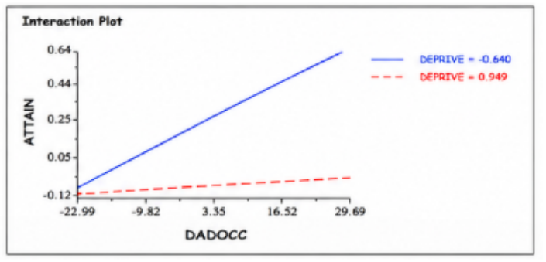
The clearest interaction is between DEPRIVE and DADOCC. The coefficient for DADOCC is 0.009418, while the interaction coefficient is -0.008490 with p < .001. This means that father occupational status has a positive association with attainment in non-deprived neighborhoods, but this positive slope becomes much weaker in deprived neighborhoods.
For students in non-deprived neighborhoods, the DADOCC slope is approximately 0.00942. For students in deprived neighborhoods, the combined slope is 0.009418 + (-0.008490) = 0.000928
Thus, one relatively steep positive line for the non-deprived group and one much flatter line for the deprived group. This pattern is what the model implies: the advantage associated with higher father occupational status is reduced when students live in deprived neighborhoods.
The other interaction terms are not statistically significant: DEPRIVE × P7READ has p = .129, DEPRIVE × DADUNEMP has p = .750, and DEPRIVE × MALE has p = .521. Therefore, the strongest evidence for a moderation effect is specifically for father occupational status rather than for all child-level covariates.
The results show that neighborhood deprivation is negatively related to achievement, even after controlling for prior reading, family background, father employment, and gender. The model also suggests that deprivation weakens the positive relationship between father occupational status and achievement. However, there is not enough evidence that the deprivation effect itself varies significantly from school to school.

